1. Widget allow column customization

* Currently in widget (ex: slow pages), there is no column “Failed” like in the APM server requests. So it’s impossible to monitor the failure percentage in quick view from the dashboard

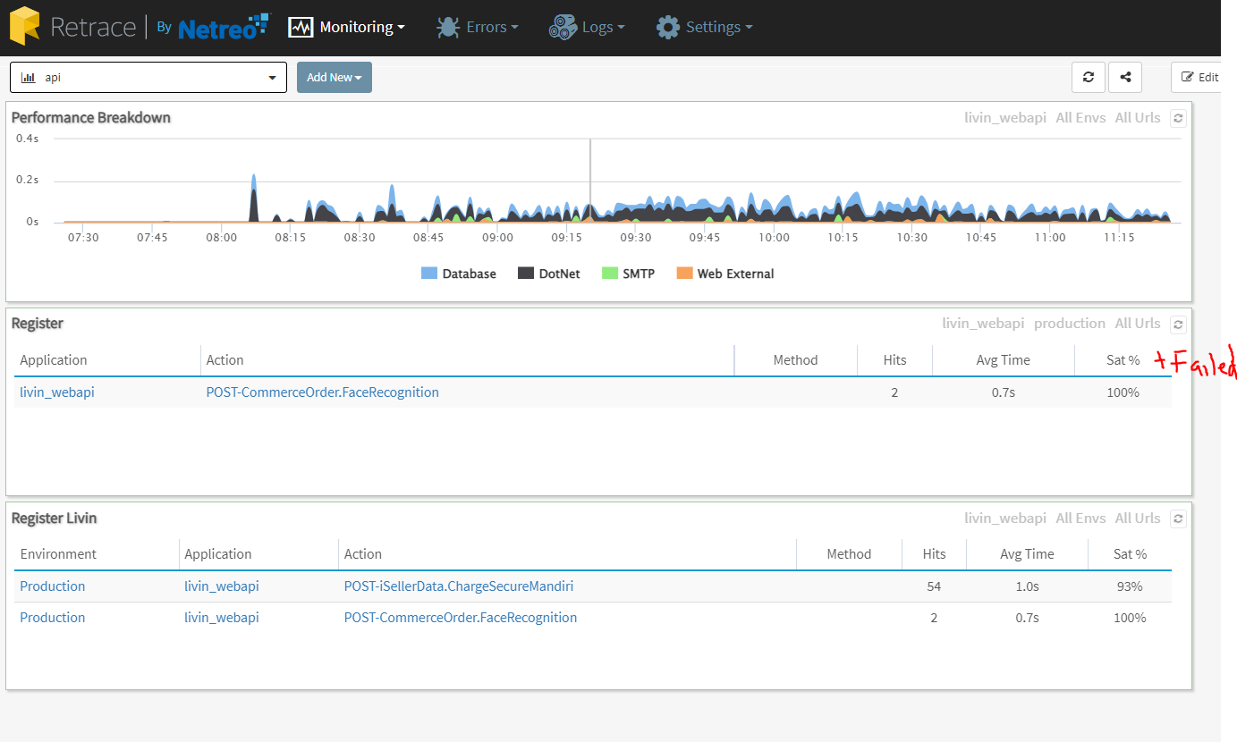

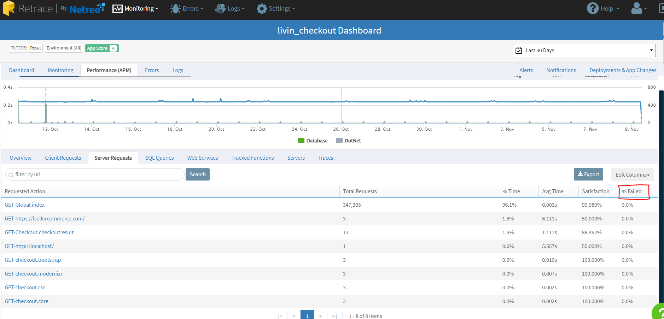

1. Widget that enables viewing external web requests, a.k.a Web Services tab of the APM+ page

* Currently in widget, can’t add “Web Service” query

